Electronic Device (IT-II) Full marks-60
Pass marks -30

1
- Explain Piecewise linear Diode Characteristics. From the square-law device given by I_{s}= A (V_{s}-V_{TR}) ² with parameter A=1mA/v² and V_{TR}=0, calculate the value of I_{s}
2+5
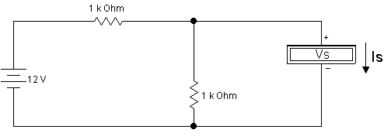

- Differentiate between insulator, conductor and semiconductor with appropriate Energy-band structure. Where does Fermi Energy level of intrinsic semiconductor lies?
8

2
- Find the output waveform (V_{out}) in the circuit below. 3+4
i)
ii)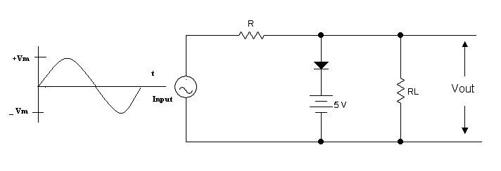
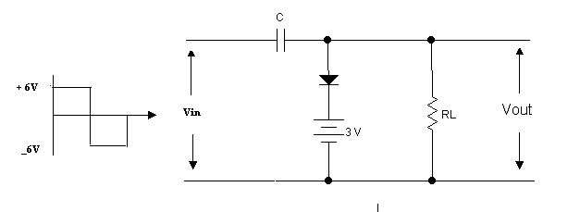

- Enumerate the advantage of Full-wave rectifier over half-wave rectifier. Also calculate the efficiency of Full wave rectifier. 8

3
a) Discuss briefly about Junction-Diode Switching Times. 7

- Calculate the value of I_{zmax} and I_{zmin} from the circuit below. 8

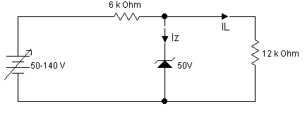

4 a) what is an Early Effects? Explain input and output characteristic curve of Common Emitter (CE) configuration. 7

b) Explain current components of NPN transistor in detail. 8

